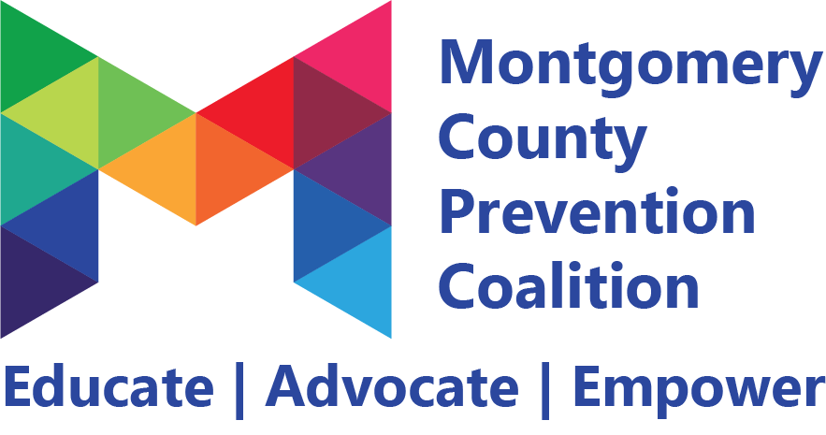
Coalition Meeting
September 28, 2018 9:00 – 11:00 am
Public Health Dayton & Montgomery County

________________________________________________________________________________________________________

Meeting Highlights and Action Plan

Agenda  Item | Key Points | Action Items
1 | Introductions  Welcoming new members:  Janeece Warfield (Wright State University)  Jim Vangrov (Montgomery County Commission)  Monica Patton (National Guard Counterdrug Task Force)  Cheryl Sells (Youth to Youth International)  Ryan Taylor (Wright State University)  Jodi Kulka (Montgomery Co. Educational Service Center)  Kevin McGhee (Central State University)  Amber Meyer (Community Services for the Deaf)  Bill Flaute (Mayor, City of Riverside)  Dan Foley (Montgomery County Commissioner)  Terence Hayes (Boys & Girls Club of Dayton)  Joseph Keferl (Wright State University)  Niraj Antani (Ohio State Representative)  Sarah Badger (Community Services for the Deaf)  Joan Bline (Oakwood City Schools)  Paula Cosby (Montgomery County ADAMHS)  Christina King (Care Source)  Kanifa Davis (Public Health- Addiction Services)
2 | The Montgomery County Prevention Coalition celebrated their accomplishments throughout the year. A few highlights that were mentioned during the meeting include:  - The development of the first marijuana toolkit in Ohio to address marijuana for medicinal purposes. Other communities are looking to adopt this toolkit and localize it in hopes of a uniform statewide prevention response.  - The alcohol committee has been working on a guide to outline practices and procedures for fairs and festivals that organizers can put in place to ensure the safety of patrons attending these events.  - The mental health committee has been working to bring awareness to Be Present campaign that shows youth the power of being present for themselves and their peers. This initiative includes a media campaign, school presentations and training for students around mental health.  - The opioid committee has developed a disposal locator that shows individuals where the closest medication disposal site is to their home, a student athlete guide to train athletic trainers, coaches and parents on how to effectively manage an opioid prescribed to a student athlete for an injury, and the development of safe storage and disposal cards as they pertain to opioids.
3 | The Montgomery County Prevention Coalition was one of two coalitions in the state of Ohio to receive the Drug Free Communities grant award through the Office of National Drug Control Policy. This grant will provide $125,000 a year for 5 years to the coalition from the federal government and Montgomery County ADAMHS has agreed to match that amount at an additional $125,000 a year for 5 years.
4 | The coalition announced the new countywide Youth Advisory Council that is being led by Youth to Youth International. The Youth Advisory Council is a group for youth leaders in each school district to join and be a voice for their community as the group works to develop countywide prevention initiatives. | Coalition members can refer high school leaders that would be appropriate for this initiative to Tristyn Eppley at teppley@mcadamhs.org
5 | The coalition is announcing its newest committee that will focus on Problem Gambling, Problem Gaming & Screen Disorder Prevention. The committee will be led by Jess Davies of the Montgomery County ESC and Antheny Petty of UMADAOP.
6 | The Schools of Excellence in Prevention program was announced. This program will allow school buildings to earn points to become a “School of Excellence in Prevention.” They can earn bronze, silver, gold, or platinum based on the amount of prevention services offered within their school building. A coordinator will be hired for this project to work closely with schools and provide technical assistance and consultation that will assist schools in implementing evidence-based prevention programs. The coordinator will also assist schools in assessing their needs and determining which prevention programs would make the most meaningful impact in their school building.
6 | Next MCPC Meeting will be Friday, November 2, 2018 from 9-11 am at Barry Staff- 230 Webster Street Dayton, OH. | Invite friends & colleagues that are interested in preventing drug use and improving mental health in Montgomery County  Register for MCPC meeting at preventionmc.org/events

☒ Refer to sign-in sheet

☐ Members present:

Generated By: Tristyn Eppley
Next Meeting: November 2, 2018 9-11 am

