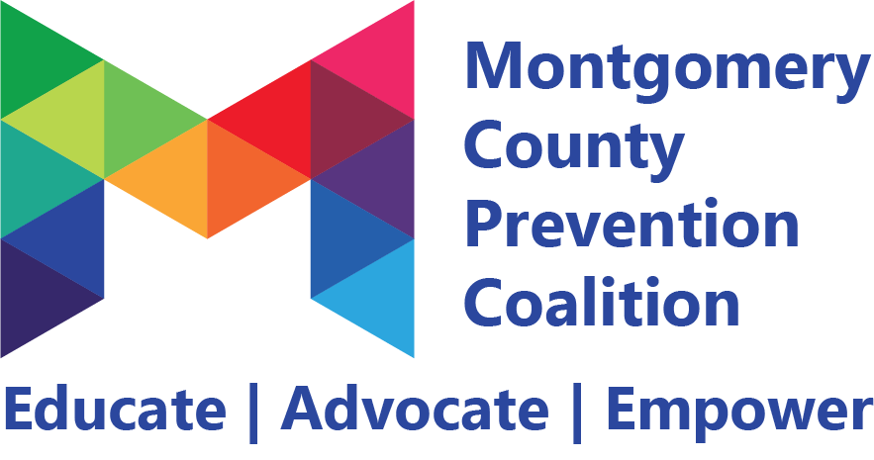
Coalition Meeting
November 2, 2018 9:00 – 11:00 am
Barry Staff

________________________________________________________________________________________________________

Meeting Highlights and Action Plan

Agenda  Item | Key Points | Action Items
1 | Introductions  Welcoming new members:  Rochelle Garner (Dayton YWCA)  Jess Davies (Montgomery Co. Educational Service Center)  Timothy McCoy (St. Joseph Orphanage)  Judith Williams (UMADAOP of Dayton)  David Rex (Daybreak)  Matt West (Daybreak)
2 | Overview of the Montgomery County Prevention Coalition and the 5 committees: alcohol prevention, marijuana prevention, opioid prevention, mental wellness, and the new problem gambling, gaming and screen disorder committee.
3 | Review of the Drug Free Communities grant aware that the coalition received through the Office of National Drug Control Policy (ONDCP) that will provide $125,000 a year for 5 years and the 100% match from Montgomery County ADAMHS that will provide an additional $125,000 a year for 5 years.  The objectives of the grant are to decrease alcohol use and non-prescribed pharmaceutical opioid use among 12th graders as well as increase perception of harm of marijuana among 12th graders.
4 | The coalition will move towards having an Executive Committee consisting of 4 officers that will lead coalition efforts. The four positions will include: Chair, Vice-Chair, Secretary, and Treasurer. Applications will open the week of November 5, 2018 and will be due by December 17, 2018. The elections will take place during the coalition’s January meeting. | Members interested in applying for these positions should submit their applications before December 17, 2018
5 | Committee Updates:  Opioid Committee- members participated in the DEA Take Back Day event on Saturday, October 27th and were present at 6 police stations including: Huber Heights, Butler Twp., Vandalia, Kettering, Dayton- Washington St., Dayton- Wayne Ave. The group handed out prevention materials to over 100 individuals.  Marijuana Committee- the group has launched their marijuana toolkit. They have partnered with the Miami Valley OVI Task Force and are planning a press release around the “Drive High Get an OVI” campaign in January. The group is also planning an Environmental Scan Scavenger Hunt for the Spring.  Alcohol Committee- promoted their “Parents Who Host Lose the Most” campaign during the DEA Take Back Day events. The group is preparing the meet with the Dayton Dragons to discuss low-risk drinking policies.  Mental Health Committee- working to prioritize strategies and will go through a prioritization process at their next meeting in November.
6 | Next MCPC Meeting will be Friday, January 4, 2019 from 9-11 am at Montgomery County ADAMHS 2nd Floor Training Room- 409 E Monument Ave Dayton, OH | Invite friends & colleagues that are interested in preventing drug use and improving mental health in Montgomery County  Register for MCPC meeting at preventionmc.org/events

☒ Refer to sign-in sheet

☐ Members present:

Generated By: Tristyn Eppley
Next Meeting: January 4, 2019 9-11 am

