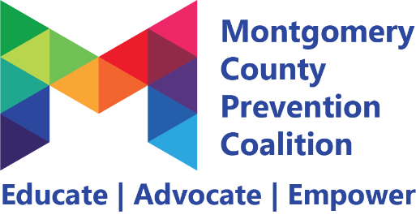
Self-Care Committee
Minutes
June 9, 2022 2-4pm via Zoom

Meeting minutes

Attendance
Wendy Berkshire, Ralph Davis, Nina Rains, Kayla Hairston, Colleen Oakes, Kelly Howard, Karen Via, Ashley Browning, Mark Bailey, Essence Jordan, Alexis Webster, Sophia DiSalvo, Adeanna Wingfield, Pat Holmes

- Personal Agreement Nina Rains 5 minutes

- Welcome/Introductions Whole Group 5 minutes

- Mindfulness Minute Wendy Berkshire 10 minutes
- Resource Strengthening

- Review Survey Kayla 30 minutes
- Gave time for members to complete survey
- 1.3 received the most support with 16 votes – Should we create our own event or support another? Check the schedule and see what events occur throughout the year to see how we could support existing events. October 29th Ashley Browing has a self-care conference. June 18th there is a fatherhood event at Island Park from 11-4 (Pat Holmes)
- 2.3 and 6.3 both received 10 votes
- 3.1 received 3 votes – Colleen will try to invite someone from juvenile court to come speak next month at our meeting to help us understand more how we could support these youth
- The majority voted to keep meetings virtual at this time
- Maybe try to do an in person meeting in August?
- Updates on School Initiative School Workgroup 30 minutes
- Self-care kits were created in collaboration with the Soft Barriers Committee and delivered to the schools we chose – Ralph delivered to Westrooke Village Elementary – Kelly wanted to deliver to City Day but no one was at the school because it was an early dismissal on the last day – Sanjii delivered kits to Dayton Smart and had students fill out messages to teachers.
- To order more kits: https://docs.google.com/forms/d/e/1FAIpQLSeMf5c6T8QcgdNZPZ64ghnsFNjmbjS295_-dA6V3ur_NmIUZQ/viewform?usp=sf_link
- Next steps: Recover events are coming up and we could include self-care kits and positive messages at the events

- Updates on Local Help Now App Resource Workgroup 30 minutes
- We wanted to put resources and information about self-care on the Local Help Now app – Colleen created a proposal and submitted it with her ideas and we are looking at launching this initiative this fall

- Coalition Updates Whole Group 10 minutes
- June 27- July 1st Ralph and Kelly have a summer camp through the YWCA
- NCCJ has Any Town starting next week awebster@nccjgreaterdayton.org nccjgreaterdayton.org/anytown
- July 8 from 10-12 – full coalition meeting (hybrid meeting) registration is required
- September 9 from 10-12 – full coalition meeting – moved due to the holiday

Commitments
- send out the survey one more time before the July meeting to get more feedback
- invite juvenile court to July meeting
- invite Mark to share about NAMI’s teen program at an upcoming meeting

Next Meeting July 14, 2022 from 2-4pm via Zoom

