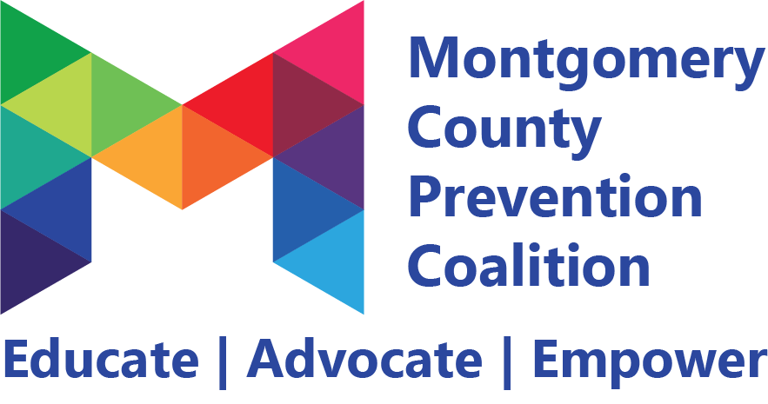
Coalition Meeting
January 4, 2019 9:00 – 11:00 am
Montgomery County ADAMHS

________________________________________________________________________________________________________

Meeting Highlights and Action Plan

Agenda  Item | Key Points | Action Items
1 | Introductions  Welcoming new members:  Layla Ahlers (Girl Scouts of Western Ohio)  Vivica Montgomery-Gibson (CareSource)  Stephanie Stratton (South Community)  Casey Smith (Public Health- DMC)  Sarah Dahlston (Planned Parenthood)  Hols Fischer (Ohio Inter-Service Family Assistance Committee)
2 | Overview of the Montgomery County Prevention Coalition and the 5 committees: alcohol prevention, marijuana prevention, opioid prevention, mental wellness, and problem gambling, gaming and screen disorder committee.
3 | Coalition members voted on Officers to serve on the Montgomery County Prevention Coalition’s Executive Board. The officers chosen are as follows:  President- Barbara Marsh (Public Health- Dayton & Montgomery County), Vice-President- Bill Hoying (Haven Behavioral Hospital), Secretary- Amber Meyer (Community Services for the Deaf), Treasurer- Amy Wendell (CareSource)
4 | Belon Hill of Youth to Youth International provided updates on the Youth Advisory Board that will be working in conjunction with the coalition. The Youth Advisory Board is open to all high school students in Montgomery County interested in behavioral health advocacy work. Their next meeting will take place Saturday, January 26th from 10 am – 12 pm at the Dayton Metro Library- downtown location. | Coalition members interested in serving as a youth advisor or know of a high school student that is interested should contact Belon Hill at bhill@youthtoyouth.net
5 | Committee Updates:  Opioid Committee- has distributed over 1,000 warning labels for pharmacists to place on opioid prescriptions. The group has printed 10,000 more for distribution. The group is currently talking to Dayton Children’s Hospital in hopes of implementing a medication disposal location in the Old North Dayton neighborhood. They are reaching out to several neighborhood associations in hopes of advocating for more disposal locations around the county. The group has developed a campaign targeted at patients in hopes that they’ll ask more questions about their prescriptions.  Marijuana Committee- the group continues to partner with area organizations on the “Drive High Get an OVI” campaign. They are planning an environmental scan & scavenger hunt this Spring and members are encouraged to sign up if they’re interested in participating. The committee is working with the Youth Advisory Board to plan a “Take Back 420” social media project.  Alcohol Committee- the group is working on the development of a campaign discouraging parents from hosting underage parties and providing alcohol. The group continues to look at ways to expand the Alcohol Server Knowledge training and plans to meet with the Dayton Dragons to discuss ways to promote alcohol safety at their events.  Mental Health Committee- the group has prioritized the development and implementation of Alateen and other COA groups in area schools and organizations. The group is currently researching best practices around the support groups and looking for ways to tie prevention education into the model. | Join a committee by rsvp’ing at preventionmc.org/events
6 | Next MCPC Meeting will be Friday, March 1, 2019 from 9-11 am at Barry Staff- 230 Webster Street Dayton, OH | Invite individuals that are interested in preventing drug use and improving mental health in Montgomery County  Register for MCPC meeting at preventionmc.org/events

☒ Refer to sign-in sheet

☐ Members present:

Generated By: Tristyn Eppley
Next Meeting: March 1, 2019 9-11 am

