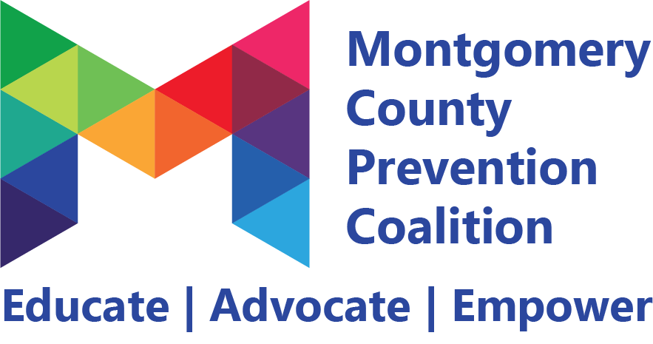
Coalition Meeting
March 2, 2018 9:00 – 11:00 am
Public Health Dayton & Montgomery County

________________________________________________________________________________________________________

Meeting Highlights and Action Plan

Agenda  Item | Key Points | Action Items | Owner(s)
1 | Introductions  Welcoming new members:  Melissa Earich- New Lebanon Schools  Shelagh McGovern- Better Business Bureau  Lauren White- Indigo Media  David Lobo- East End Community Services
2 | Recap of CADCA Training- many of the members attended and discussed skills they took away from the training including: logic model development, determining gaps in data, and strategic planning  Ashley Mack and Tristyn Eppley also discussed the CADCA Youth training that is being planned with the DEA scheduled for the end of the summer | Fill out Coalition Involvement Agreements if they weren’t completed at the meeting and return to Tristyn Eppley- teppley@phdmc.org | Coalition Members
3 | Barb Marsh announced that the Montgomery County Prevention Coalition is applying for the Drug Free Communities grant through the Office of National Drug Control Policy. This grant can bring up to $125,000 a year into the county for up to 10 years.  Coalition members signed Coalition Involvement Agreements to show representation from the 12 sectors
4 | Andrea Hoff provided an overview of the “7 Strategies for Community Change.” These include:  - Provide Information  - Enhance Skills  - Provide Support  - Enhance Access/Reduce Barriers  - Change Consequences  - Change Physical Design  - Develop or Modify Policy | Send out Mental Health First Aid Adult Trainer Training through OACBHA (Ohio Association County Behavioral Health Authorities)  Send out information from Mental Health First Aid Training showing that talking to youth about substances or mental health doesn’t cause risky behaviors | Tristyn Eppley  Andrea Hoff
5 | Committees announced the local conditions that came out of the CADCA Training and announced strategies that they’ll be working on through September 2019.  *Please see meeting presentation for committee strategies and local conditions | Sign up for committee meetings at preventionmc.org/events  Marijuana Committee:  3/14/18 2-4 pm  Public Health- 117 S Main Street Dayton (3rd Floor)  Alcohol Committee  3/19/18 2-3:30 pm  Mont. Co. Children Services- 3304 N Main Street Dayton  Mental Health Committee:  3/26/18 9-11 am  Haven Behavioral-  1 Elizabeth Pl Dayton (10th Floor)  Opioid Committee  3/27/2018 2-4 pm  Mont. Co. ADAMHS  409 E Monument St Dayton | Coalition Members
7 | Tristyn Eppley announced the new member center where coalition members will have access to past meeting handouts, photos, and logic models. To access visit preventionmc.org/membercenter  Password- mcpcoalition
7 | Next MCPC Meeting will be Friday, May 4, 2018 from 9-11 am at Public Health Dayton & Montgomery County- 117 S Main St Dayton (3rd Floor) | Invite friends & colleagues that are interested in preventing drug use in Montgomery County  Register for MCPC meeting at preventionmc.org/events | Coalition Members

☒ Refer to sign-in sheet
Generated By: Tristyn Eppley
Next Meeting: May 4, 2018 9-11 am

